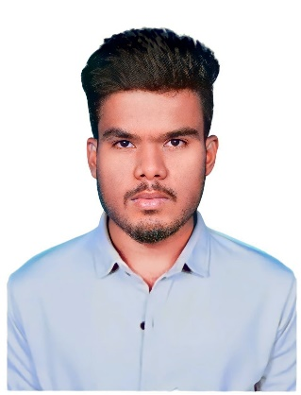**KARTHICK V**

**Phone** :9360995463

**Email id** : karthickvenkatesan45@gmail.com

**LinkedIn**: <https://www.linkedin.com/in/karthick-09-v/>

**GitHub** : <https://github.com/karthick-09V>

**Address** : 104, Poyer Street, Palaniyapuri, Salem, Attur, Tamilnadu, 636108

**CAREER OBJECTIVE:**

To land a job with a reputed organization where I can make the best use of my abilities and business studies training.

# EDUCATION QUALIFICATION:

|  |  |  |  |  |  |
| --- | --- | --- | --- | --- | --- |
| **S.NO** | **COURSE** | **INSTITUTION** | **BOARD/**  **UNIVERSITY** | **PERCENTAGE/**  **CGPA** | **YEAR OF PASSING** |
| 1 | B.E Computer Science and Design | Karpagam  Academy of Higher Education | Deemed  University | 8.06* | 2025 |
| 2 | HSC | Sri SRV Matric  Higher Secondary  School | State Board | 85% | 2021 |
| 3 | SSLC | Sri SRV Matric  Higher Secondary  School | State Board | 76% | 2019 |

**AREA OF INTEREST:**

1. Programming
2. Artificial Intelligence
3. Machine Learning
4. Designing (UI/UX)

**TECHNICAL SKILLS:**

1. C Programming
2. Python Programming
3. Java Programming
4. HTML
5. CSS
6. Flutter
7. Figma

**CERTIFICATIONS:**

1. Awarded a certification in Cancer Care AI and placed third in Cancer Hackathon conducted by StartupTN and Karpagam Academy of Higher Education
2. Certified for the course ‘Introduction to Internet of Things’ with consolidated score of 60% (Elite) in NPTEL
3. Certified in Coursera
4. Grammar and Punctuation
5. Excel Basics for Data Analysis
6. Data Analysis with Python
7. Certified in Infosys Springboard
8. Programming in C
9. Introduction to Python
10. Basics of Python
11. Programming Concepts in Python
12. The Complete Python Course
13. Database Management System

**INTERNSHIP:**

1. Undergone an Internship Conducted by Pantech E-Learning on Web-Development Full stack (React JS) for 30 days in 2023
2. Undergone an Internship Conducted by Pantech E-Learning on Python Programming for 15 days in 2022

**PROJECT:**

1. **Cancer Care AI** - Using GAN and ML technologies, Created a ground-breaking smartphone application to identify oral cancer pre-malignancy. This creative idea helps people who don't have the facility to reach the healthcare instantly. The interface of the program is easy to use, making it suitable for a wide range of users. It is a significant advancement in healthcare accessibility that makes early identification and intervention possible. This project demonstrates my proficiency in using cutting-edge technology to provide preventative healthcare solutions.
2. **Dust Sensing** - Created a tool that detects small dust particles using an Arduino kit and a PM 2.5 dust sensor. Through the monitoring of dust levels and the suggesting of cleaning when thresholds are crossed, this innovation assures cleaner environments. Hospital operation theaters are the best example of where the fine dusts are not engaged in workplaces.

**STRENGTH:**

1. Listener
2. Punctual
3. Adaptable
4. Team Work
5. Communication

**HOBBY:**

1. Listening to music

**DECLARATION:**

I hereby declare that all the information furnished above is true to the best of my knowledge and belief

[KARTHICK V]